Index

|  |  |  |  |
| --- | --- | --- | --- |
| Sr. No. | Particulars | Page No. | Sign |
| 1. | Introduction   * 1. Project Profile   2. Introduction   3. Scope & Objective   4. Project Goal   5. Project Category | 2 |  |
| 2. | Environment description   * 1. Hardware and software requirement   2. Application area of this system | 8 |  |
| 3. | Analysis Reports   * 1. Drawback of the current System   2. Requirement Analysis   3. Requirement specification   4. Proposed system   5. Advantage of the Proposed System | 10 |  |
| 4. | Software diagram  4.1 Admin & Student activity diagram  4.2 Admin & Student usecase diagram  4.3 Admin usecase diagram  4.4 E.R. Diagram  4.5 Sequance digram  4.6 Class diagram | 16 |  |
| 5. | Database design | 24 |  |
| 6. | Testcase design | 27 |  |
| 7. | Project images | 30 |  |
| 8. | Future scope | 43 |  |
| 9. | Bibiliography | 44 |  |

1. **Introduction**
   1. Project profile

|  |  |
| --- | --- |
| Project Name | “Evently” |
| Project type | Full stack website |
| Duration | 5 month |
| Tools   * Front-End * Back-End * Code Editor * Rest Testing | * JSF , Bootstrap , CSS * JPA , EJB , Rest , Jersy Client * NetBeans * PostMan |
| Operating System | Windows 11 |
| Project Guide | Prof. Hiral ma’am |
| Submitted By | Nevil Mistry |
| Submitted To | “J.P.Dawer institute of Information Science and Technology - BSc (IT) & MSc (ICT)” |

1.2 Introduction

The Event Management Project is a comprehensive system designed to streamline and automate the process of planning, organizing, and executing events. In the dynamic landscape of event management, efficiency and precision are paramount. This documentation serves as a guide to understanding the key components, functionalities, and benefits of Event Management Project.

The project is built on JavaEE, incorporating Java Persistence API (JPA) for efficient data handling and Enterprise JavaBeans (EJBs) for modular development. The integration of RESTful APIs through JAX-RS and Jersey client ensures seamless communication. Contexts and Dependency Injection (CDI) beans manage dependencies, enhancing code modularity. JavaServer Faces (JSF) enriches the user interfac. This amalgamation of technologies results in a robust and scalable solution, combining enterprise-level Java frameworks with modern web technologies for an optimal application.

The Admin Panel serves as the command center for efficient management, encompassing CRUD operations for events and categories, as well as overseeing winners, awards, sponsors, and total users. With an interactive dashboard, administrators can effortlessly monitor key metrics and statistics. The panel also facilitates password updates and allows administrators to view and manage their own profiles, providing a centralized hub for comprehensive control and oversight.  
  
The Student Panel offers a user-centric experience with features such as event browsing, detailed event information, group creation, and enrollment capabilities. Students can seamlessly navigate through group details, track their participation data, and manage their profiles. The panel also empowers students to update their passwords, providing a user-friendly interface that enhances their engagement with the event management system.

1. 3 Scope & Objective

1. User-Friendly Interface:

The project aims to provide an intuitive and easily navigable user interface to ensure a positive experience for both administrators and students.

Emphasis will be placed on clear layouts, easy access to functionalities, and responsive design for optimal usability across devices.

1. Comprehensive Event Creation and Management:

The system will allow administrators to create, configure, and manage events efficiently, including customizable parameters such as event type, date, and location.

Event management functionalities will encompass features like participant registration, resource allocation, and task assignment.

1. Integration of Modern Technologies:

Leveraging JavaEE, JPA, EJBs, RESTful APIs, JSF, and other relevant technologies will be a key component, ensuring a robust and scalable architecture.

Integration with Bootstrap and CSS will be employed to enhance the visual appeal and responsiveness of the user interface.

1. Role-Based Access Control:

The project will implement role-based access control to ensure that different user roles (administrators, students) have appropriate access permissions.

Access levels will be defined to maintain data security and uphold the principle of least privilege.

1. Interactive Dashboards and Reports:

Both administrators and students will have access to interactive dashboards providing real-time insights into key metrics, participation data, and event statistics.

Customizable reports and visualizations will facilitate data-driven decision-making.

1. Group Creation and Management:

Students will have the ability to create groups, enroll in existing groups, and manage group details.

This feature encourages collaboration and enhances the social aspect of event participation.

1. Security and Data Privacy:

Utilizes JWT for robust authentication and authorization processes.

Implements hashed passwords for secure storage and data privacy.

Ensures compliance with data protection regulations.

Emphasizes strong security measures throughout the project.

1. Password Management and User Profiles:

Both administrators and students will have the capability to update passwords securely.

Users will be able to view and manage their profiles, promoting a personalized and user-centric experience.

1.4 Project Goal:

* Develop a comprehensive, centralized platform serving as a one-stop solution for event management.
* Replace the need for scattered social media platforms by providing students with a dedicated website.
* Ensure all-encompassing event information, including details about sponsors, awards, and winners.
* Streamline the event lifecycle, from listing to completion, fostering a cohesive and efficient event management experience.
* Minimize the need for students to rely on external social media platforms like WhatsApp, Instagram, or Classroom for event-related communication.
* Provide an all-encompassing solution that caters to various aspects of event management in one dedicated space.

1.5 Project category

The Event Management Project falls under the category of "**Event Management Systems**."

This category encompasses software applications designed to streamline and enhance the planning, coordination, and execution of events.

The project specifically focuses on providing a centralized platform for managing various aspects of events, including event creation, participant registration, sponsorship details, award information, and winner determination. It aims to consolidate event-related activities into a cohesive system, eliminating the need for students to rely on external social media platforms.

The project aligns with the broader domain of Information and Communication Technology (ICT) and leverages technologies such as JavaEE, JPA, EJBs, RESTful APIs, JSF, Bootstrap, and CSS to create a comprehensive and efficient solution for event management.

By consolidating event-related information, including sponsors, awards, and winners, the system minimizes reliance on external social media channels. This categorization places the project at the intersection of Information and Communication Technology (ICT) and event coordination, aiming to streamline processes and enhance user engagement within a dedicated online space.

**2. Environment Description**

2.1 Hardware and software requirement

For Admin

|  |  |
| --- | --- |
| Software | Netbeans,Chrome,Javaee,MySQL workbench |
| DataBase | Mysql |
| Operating System | Windows,MacBook,Linux |
| RAM | 512 MB |
| Hard Disk space | 1GB(Minimum) |
| Web Browser | Any browser |

For Student

|  |  |
| --- | --- |
| Operating System | Windows, MacBook,Linux |
| RAM | 512 MB |
| Hard Disk space | 1GB(Minimum) |
| Web Browser | Any browser |

For documentation

|  |  |
| --- | --- |
| Software | MS Word |

2.2 Application area of this system

1. Education Institutions :

Manage and coordinate academic and extracurricular events, including seminars, workshops, and cultural activities.Facilitate student engagement, participation tracking, and collaboration in educational events.

2. Corporate Sector:

Streamline the planning and execution of corporate events such as conferences, seminars, and team-building activities.

Enhance communication and coordination among employees for company-wide events.

3. Event planning company : Coordinate fundraising events, charity functions, and awareness campaigns seamlessly.

Manage volunteers, sponsors, and donors effectively for various philanthropic initiatives.

4: Entertainment and Sports Industry:

Organize and manage entertainment events, concerts, and sports competitions.

Enhance audience interaction and engagement during live performances.

5. Trade Shows and Exhibitions:

Facilitate the organization and execution of trade shows, exhibitions, and industry conferences.

Manage exhibitor and attendee details, booth assignments, and event logistics.

Healthcare Sector:

The versatility of the Event Management System makes it applicable in a wide range of industries where efficient planning, coordination, and execution of events are essential for success.

**3. Analysis Reports**

3.1 Drawback of the current System

1. Limited Admin-Student Communication:

The system may have limitations in facilitating direct and real-time communication between administrators and students. This could potentially hinder immediate issue resolution, clarification of queries, or timely dissemination of important information related to events.

1. Absence of Code Submission Form or GitHub Integration:

The absence of a dedicated submission form for code or integration with GitHub may pose a limitation for events requiring code submissions. This could inconvenience participants and organizers who prefer a streamlined process for submitting and reviewing code contributions.

1. Lack of Student-to-Student Communication for Group Creation:

The system may lack features for direct communication among students during the group creation process. This limitation could affect the collaborative aspect of event participation, hindering students' ability to form groups efficiently and discuss strategies.

1. Inability to Designate Group Leaders during Creation:

The system might not offer a mechanism for users to designate a group leader during the group creation process. This omission could lead to ambiguity in group dynamics, potentially causing challenges in decision-making and coordination within the group.

1. Absence of Student Feedback Mechanism:

The system lacks a dedicated mechanism for students to provide feedback on specific events. Without this feature, valuable insights, suggestions, and constructive criticism from participants are not collected, hindering the organizers' ability to assess the success of events and make informed improvements for future planning.

3.2 Requirement Analysis

User Roles and Permissions: Define and categorize user roles such as administrators, students, and sponsors.Specify access permissions for each role to ensure secure and controlled system interaction.

Event Creation and Configuration: Enable administrators to create, configure, and manage events with details like type, date, and location.Include options for setting event parameters, such as participant limits and registration deadlines.

Participant Management: Implement a user-friendly interface for participant registration, ensuring ease of use.Provide features for managing participant details, tracking registrations, and handling cancellations.

Group Creation and Communication: Allow students to create and join groups for collaborative participation in events. Facilitate direct communication among students within the system to enhance group coordination.

Sponsor and Award Details: Include a comprehensive section for sponsors, allowing administrators to manage sponsorship details. Specify a mechanism for adding and showcasing awards associated with each event.

Winner Determination: Designate a process for administrators to determine and declare event winners .Ensure transparency and fairness in the winner selection process.

Interactive Dashboards and Reports: Develop interactive dashboards for administrators and students, providing real-time event insights. Include customizable reports and visualizations to aid in decision-making and analysis.

Security Measures: Utilize JWT for secure authentication and authorization processes. Implement hashed passwords and robust encryption methods to safeguard user credentials.

Feedback Mechanism: Introduce a system for students to provide feedback on specific events. Collect and analyze feedback to assess event success and improve future planning.

Scalability: Design the system to scale with the increasing complexity and size of different events. Consider future enhancements and ensure the system's ability to handle growing user bases.

3.3 Requirement specification

The Event Management System aims to provide a robust and user-friendly platform that caters to the diverse needs of administrators and students. This specification outlines the essential features and functionalities to ensure seamless event planning, coordination, and execution. The system will support multiple user roles, including administrators responsible for event setup and management, as well as students participating in and organizing events.

To enhance user engagement, interactive dashboards will provide real-time insights, and a feedback mechanism will allow students to contribute their perspectives on events. The requirement specification emphasizes data privacy, compliance with regulations, and cross-browser compatibility.

Admin

The admin dashboard serves as the central control hub for administrators, offering a comprehensive overview of the entire event management system.

* Login

The admin can login like a user and can access the admin dashboard

* Event Creation:

Admins can create and configure new events, defining key parameters such as event type, date, location, and participant limits.

* Participant Management:

Manage participant details, track registrations, within the admin dashboard.

* Group Administration:

Monitor and facilitate group creation among students, ensuring effective collaboration during event participation.

* Sponsor and Award Management:

Admins can add, edit, or remove sponsors associated with events, as well as manage awards to be presented.

* Winner Determination:

Admins have the authority to determine event winners, ensuring transparency and fairness in the selection process.

User

**Login:**

Authenticate into the system securely, providing access to personalized event management features.

**Register:**

New users can create an account, providing necessary information for event participation.

**Home - List of Events:**

View a comprehensive list of upcoming events, facilitating easy navigation and event selection.

**Event Details Page:**

Access detailed information about each event, including type, date, location, and registration options. Option to create a group for collaborative event participation.

**Group Details Page:**

Students can view details of the groups they are a part of, fostering effective communication and coordination.

**Participation Page:**

Access a dedicated page to view personal participation details, including registered events and participation status.

**Winner Page:**

View details about personal victories and achievements in events.

**Change Password:**

Securely reset the password in case of to change or compromised credentials.

**See Profile:**

View and manage personal profiles, including the ability to see information for a personalized experience.

3.4 Proposed system

* Admin
* Admin can Login
* Admin can view dashboard
* Admin can perform CRUD of the event
* Admin can perform CRUD of the Category
* Admin can read, create and delete award, winner of the event, sponsor of the event
* Admin can see participation data
* Admin can see User details except password
* Admin can see own profile
* Admin can change the password
* Admin can sign-out
* Student
* Student can register
* Student can login
* Student can see Event in the home page
* Student can see Event details page in event details page
* Student participate in event
* Student can create a group
* Student can participate in already existed group
* Student can see group details of the event
* Student can see own participation of the event
* Student can own profile
* Student can Sign out.

3.5 Advantage of the Proposed System

1. Login security insure that only authorise user can access to the platform

2. Website can maintain the award, sponsors, events, users, awards, winner details and other information .

3. Proposed system can allow for the quick updating of the records.

4. Admin can access information easily and quickly.

5. The platform is built on the open source technologies so cost of the website is reduces.

**4. Software Diagram**

4.1 Activity Diagram

1. Admin

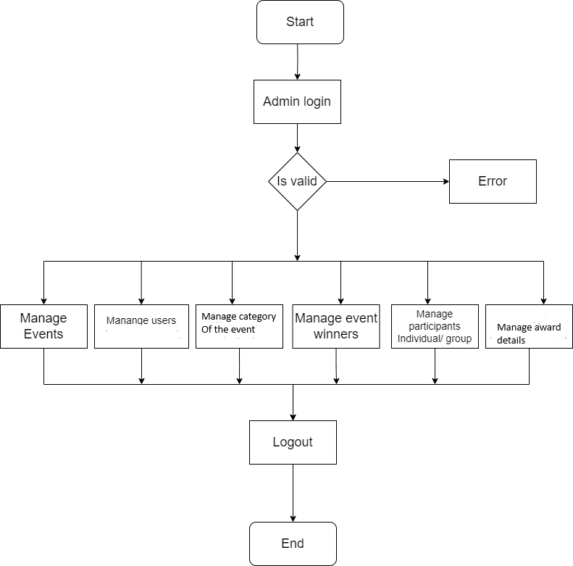

1. Student

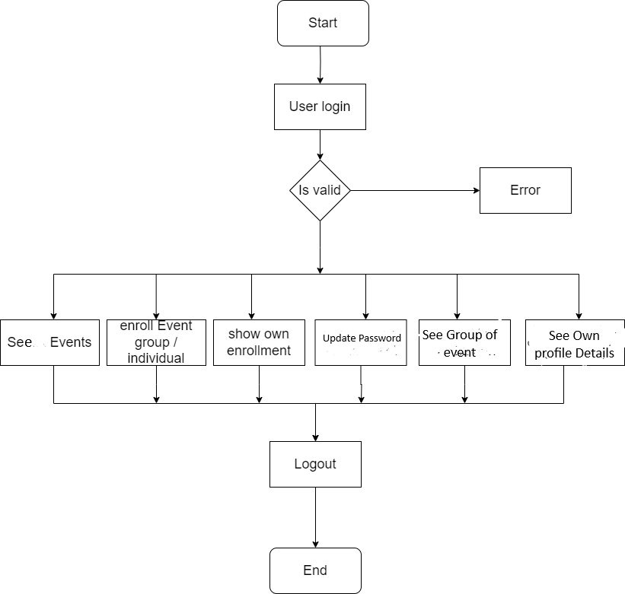

**4.2 Usecase Diagram**

1. Student

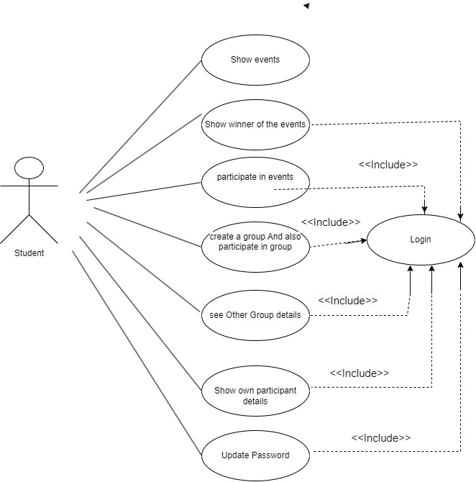

1. Admin

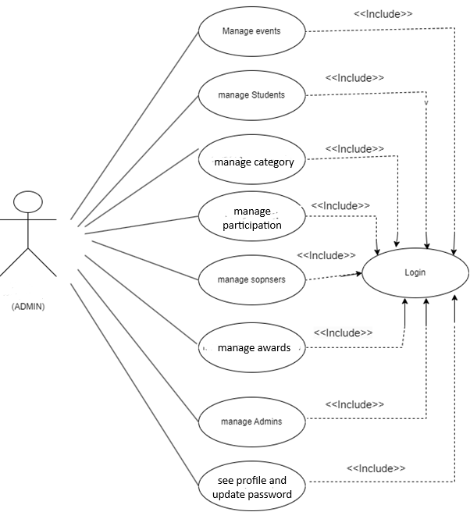

**4.3 Entity relationship diagram**

* 1. Sequence Diagram

1. Admin –

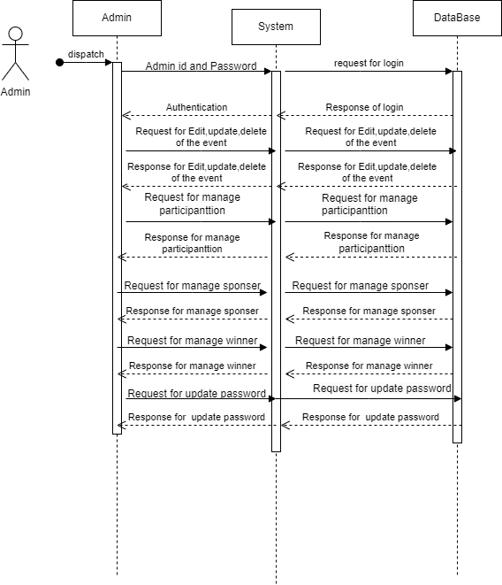

2. Student – Sequence diagram

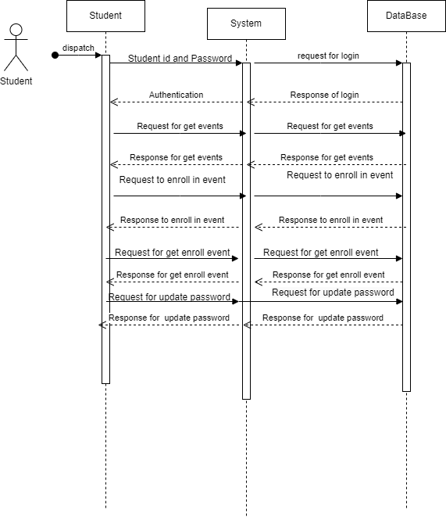

* 1. Class digram

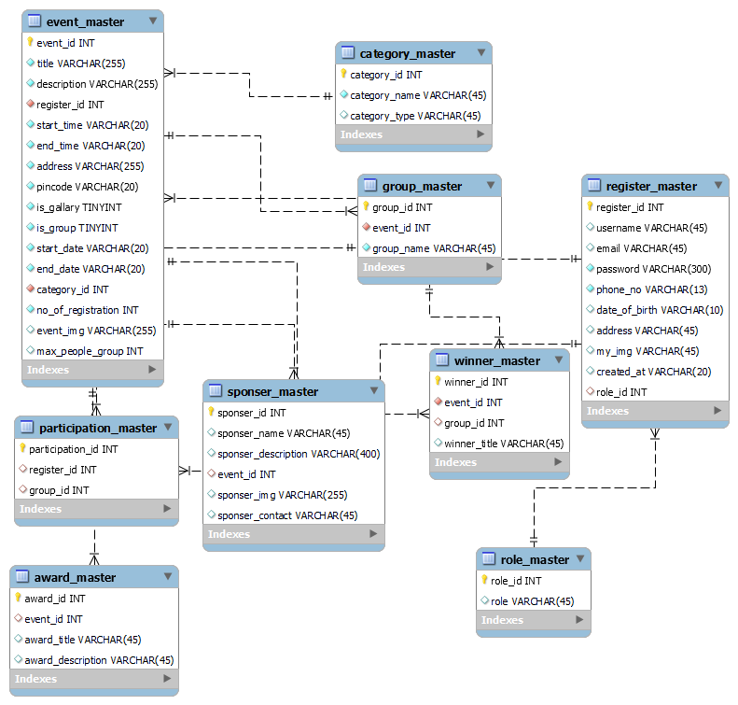

**Database Design**

Event_master

|  |  |  |  |  |
| --- | --- | --- | --- | --- |
| Column Name | Data Type | Description | Constraint | Null/Not Null |
| event_id | INT | Unique identifier for the event | Primary Key, Auto Inc | Not Null |
| event_title | VARCHAR(100) | Title of the event |  | Not Null |
| description | TEXT | Description of the event |  | Not Null |
| orgnizer_id | INT | It reference to the register master primary key | Foreign Key | Not Null |
| start_time | TIME | Start time of the event |  | Not Null |
| end_time | TIME | End time of the event |  | Not Null |
| address | VARCHAR(255) | Address where the event will take place |  | Not Null |
| pincode | VARCHAR(10) | Pincode of the event location |  | Not Null |
| start_date | DATE | Start date of the event |  | Not Null |
| End_date | DATE | End date of the event |  | Not Null |
| no_of_registration | INT | Number of registrations for the event |  | Not Null |
| category_id | INT | Identifier for event category | Foreign Key | Not Null |

Sponser_master

|  |  |  |  |  |
| --- | --- | --- | --- | --- |
| Column Name | Data Type | Description | Constraint | Null/Not Null |
| sponser_id | INT | Unique identifier for the sponsor | Primary Key | Not Null |
| event_id | INT | Foreign key to the event table | Foreign Key (FK) | Not Null |
| sponser_name | VARCHAR(100) | Name of the sponsor |  | Not Null |
| sponser_contact | VARCHAR(20) | Contact information for the sponsor |  | Null |
| Context_details | VARCHAR(20) | Description of the sponsor contect |  | Null |

Award_master

|  |  |  |  |  |
| --- | --- | --- | --- | --- |
| Column Name | Data Type | Description | Constraint | Null/Not Null |
| award_id | INT | Unique identifier for awards | Primary Key | Not Null |
| event_id | INT | Foreign key to event table | Foreign Key (FK) | Not Null |
| award_title | VARCHAR(255) | Title of the award(EX: first ,second,third) |  | Null |
| Award_description | VARCHAR(255) | Description of award |  | Null |

Category_master

|  |  |  |  |  |
| --- | --- | --- | --- | --- |
| Column Name | Data Type | Description | Constraint | Null/Not Null |
| category_id | INT | Unique identifier for the category | Primary Key | Not Null |
| category_name | VARCHAR(255) | Name of the category |  | Not Null |
| category_type | VARCHAR(50) | Type of the category (e.g., "online", "offline", etc.) |  | Not Null |

Winner_master

|  |  |  |  |  |
| --- | --- | --- | --- | --- |
| Column Name | Data Type | Description | Constraint | Null/Not Null |
| winner_id | INT | Unique identifier for each winner record | Primary Key | Not Null |
| event_id | INT | Foreign key referencing the event where winner participated | Foreign Key (event_master.event_id) | Not Null |
| Register_id | INT | Foreign key referencing the user who won | Foreign Key (user_table.user_id) | Not Null |
| Winner_title | INT | Title of the winner(ex:first,second,third) |  | Nullable |

participant_master

|  |  |  |  |  |
| --- | --- | --- | --- | --- |
| Column Name | Data Type | Description | Constraint | Null/Not Null |
| participant_id | INT | Unique identifier for each participant | Primary Key,auto increment | Not Null |
| Group_id | INT | Identifier for the associated groupMaster table | Foreign Key (Group.group_id) | Not Null |
| register_id | INT | Identifier for the register master | Foreign Key (registration.register_id) | Not Null |

group_master

|  |  |  |  |  |
| --- | --- | --- | --- | --- |
| Column Name | Data Type | Description | Constraint | Null/Not Null |
| group_id | INT | Unique identifier for the group | Primary Key | Not Null |
| group_name | VARCHAR(255) | Name of the group |  | Not Null |
| Event_id | Int | Event id | Foreign key of event id | Not null |

registration_master

|  |  |  |  |  |
| --- | --- | --- | --- | --- |
| Column Name | Data Type | Description | Constraint | Null/Not Null |
| register_id | INT | Unique registration ID | Primary Key | Not Null |
| username | VARCHAR(50) | User's username |  | Not Null |
| email | VARCHAR(100) | User's email address | Unique, Email Format | Not Null |
| password | VARCHAR(100) | User's password |  | Not Null |
| created_at | TIMESTAMP | Timestamp of registration | Default CURRENT_TIMESTAMP | Not Null |
| user_image | VARCHAR(255) | Path to user's profile image |  | Null |
| address | TEXT | User's address |  | Null |
| date_of_birth | DATE | User's date of birth |  | Null |
| phone_no | VARCHAR(20) | User's phone number |  | Not null |
| role_id | INT | Foreign key to role_master table | Foreign Key | Not Null |

1. **Test case design**
2. Register page

|  |  |  |  |  |  |
| --- | --- | --- | --- | --- | --- |
| # | Description | Inputted Value | Expected Result | Actual Result | Pass/Fail |
| 1 | Username (Required) | "JohnDoe" | Valid username is accepted. | Redirect to login | Pass |
| 2 | Password (Min-6, Max-10) | "P@ss123" | Password meets criteria and is accepted. | Redirect to login | Pass |
| 3 | Email (Required, Formatted) | "john.doe@example" | Email is required and must be in a valid format. | Redirect to login | Pass |
| 4 | Phone Number (Required) | "1234567890" | Phone number must be 10 digits and is accepted. | Redirect to login | Pass |
| 5 | Photo (Required) | [Uploads a valid photo] | Photo upload is successful. | Redirect to login | Pass |
| 6 | Address (Required) | "123 Main Street" | Address is required and accepted. | Redirect to login | Pass |
| 7 | Pincode (Required) | "ABCDE" | Pincode must be numeric and is required. | Give an error message | Fail |

1. Login page

|  |  |  |  |  |  |
| --- | --- | --- | --- | --- | --- |
| # | Description | Inputted Value | Expected Result | Actual Result | Pass/Fail |
| 1 | Username (Required) | "JohnDoe" | Valid username is accepted. | Redirect to Home page | Pass |
| 2 | Password (Required) | "P@ss123" | Valid password is accepted. | Redirect to Home page | Pass |
| 3 | Username Missing | "" | Display error: "Username is required." | Give an error message | Fail |
| 4 | Password Missing | "" | Display error: "Password is required." | Give an error message | Fail |
| 5 | Incorrect Username | "User123" | Display error: "Invalid username or password." | Give an error message | Fail |
| 6 | Incorrect Password | "WrongP@ss" | Display error: "Invalid username or password." | Give an error message | Fail |
| 7 | Username with Spaces | "John Doe" | Display error: "Username cannot contain spaces." | Redirect to Home page | Pass |

1. Create event page

|  |  |  |  |  |  |
| --- | --- | --- | --- | --- | --- |
| # | Test Case | Input/Action | Expected Result | Actual Result | Pass/Fail |
| 1 | Insert Valid Event | Insert valid event data | Event is successfully added to the database. | Redirect to the event display page | Pass |
| 2 | Missing Title | Insert event without a title | Database rejects the entry, indicating a title is required. | Give an error message | Fail |
| 3 | Title Exceeds Character Limit (13) | Insert event with a title of 13 characters | Database rejects the entry, indicating a title must be between 10 and 12 characters. | Give an error message | Fail |
| 4 | Missing Start Date | Insert event without a start date | Database rejects the entry, indicating a start date is required. | Give an error message | Fail |
| 5 | Invalid Pincode Format | Insert event with an alphanumeric pincode | Database rejects the entry, indicating a numeric pincode is required. | Give an error message | Fail |
| 6 | No Group Option Selected | Insert event without specifying a group option | Database accepts the entry with the default value for 'is_group'. | Give an error message | Fail |
| 7 | Insert Event with Image | Insert event with a valid image name, | Event is successfully added with the specified image Name. | Insert image successfully | Pass |
| 8 | Insert Event with Max People in Group | Insert event with a specified maximum number of people per group | Event is successfully added with the specified value for 'max_people_group'. | Insert group successfully | Pass |
| 9 | Description Exceeds Character Limit (201) | Insert event with a description exceeding 200 characters | Form rejects the entry, indicating a description must be 200 characters or fewer. | Give an error message | Pass |
| 10 | Insert Event with Invalid Category ID | Insert event with a non-existent category ID | Form rejects the entry, indicating a valid category ID is required. | Give an error message | Pass |

1. Category page

|  |  |  |  |  |  |
| --- | --- | --- | --- | --- | --- |
| # | Test Case | Input/Action | Expected Result | Actual Result | Pass/Fail |
| 1 | Insert Valid Category | Insert valid category data | Category is successfully added to the database. | Redirect to the category display page | Pass |
| 2 | Title Exceeds Character Limit (46) | Insert category with a title of 46 characters | Form rejects the entry, indicating a title must be 45 characters or fewer. | Give an error message | fail |
| 3 | Type Exceeds Character Limit (46) | Insert category with a type of 46 characters | Form rejects the entry, indicating a type must be 45 characters or fewer. | Give an error message | Fail |
| 4 | Missing Title | Insert category without a title | Form rejects the entry, indicating a title is required. | Give an error message | Fail |
| 5 | Missing Type | Insert category without a type | Form rejects the entry, indicating a type is required. | Give an error message | Fail |

**7. Project Images**

1. Student side

1. Login page

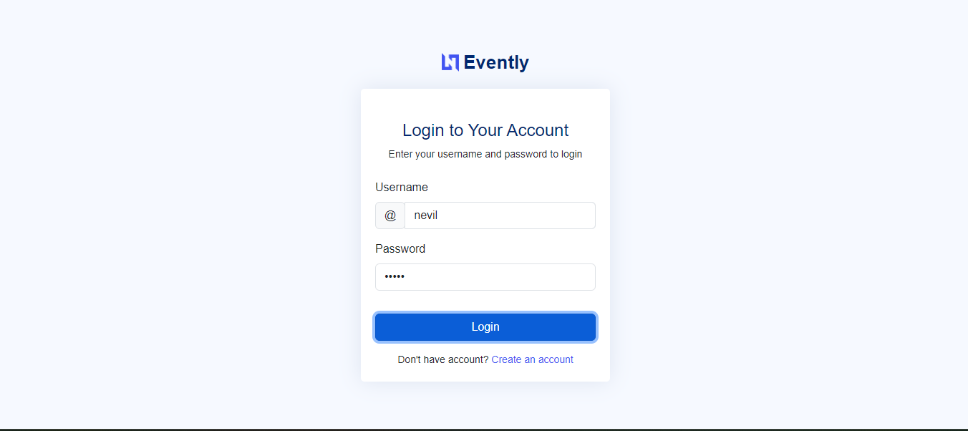

1. Register Page

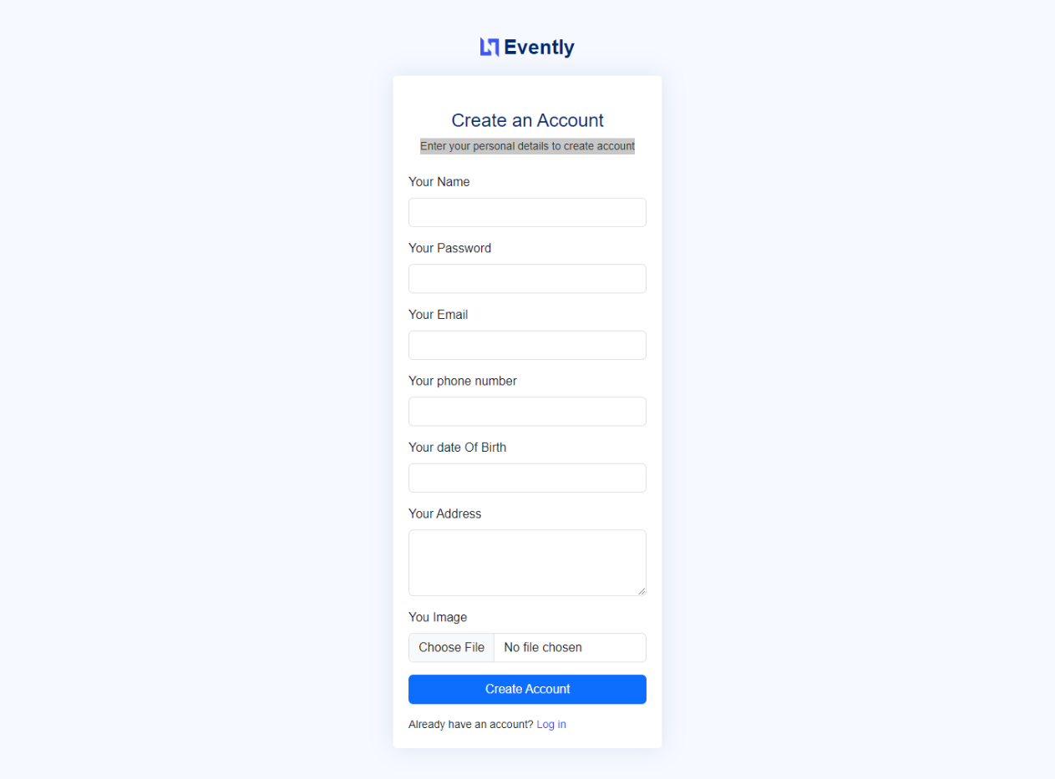

1. Home page

.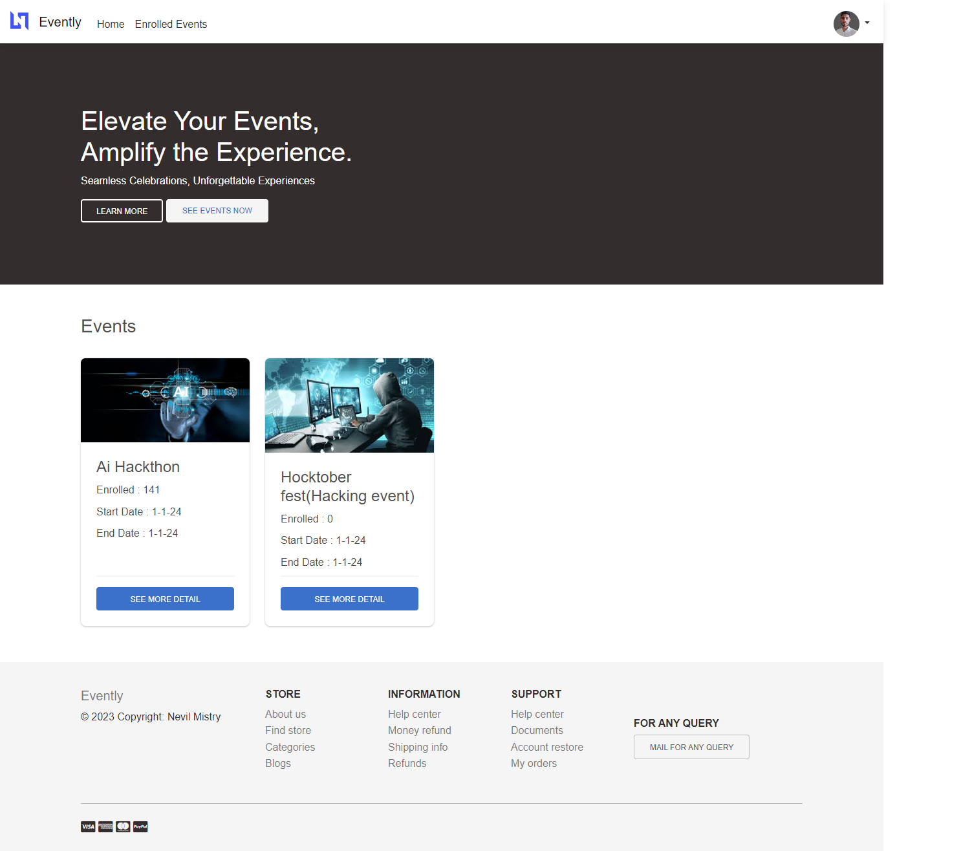

1. Event details page

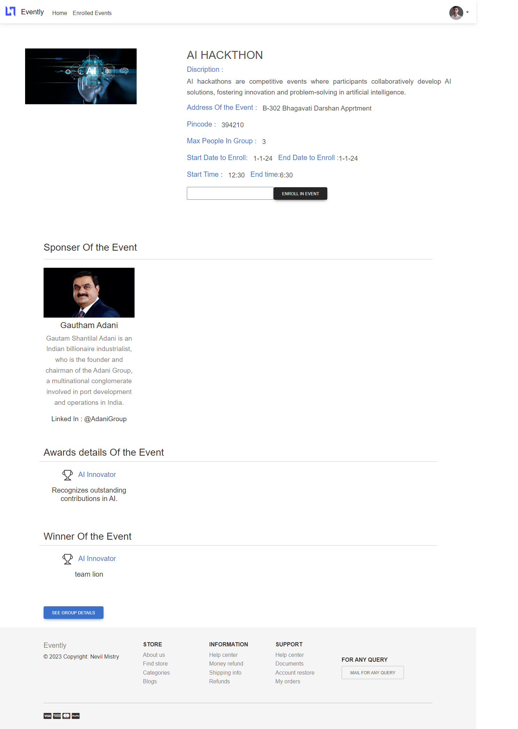

1. Profile details page

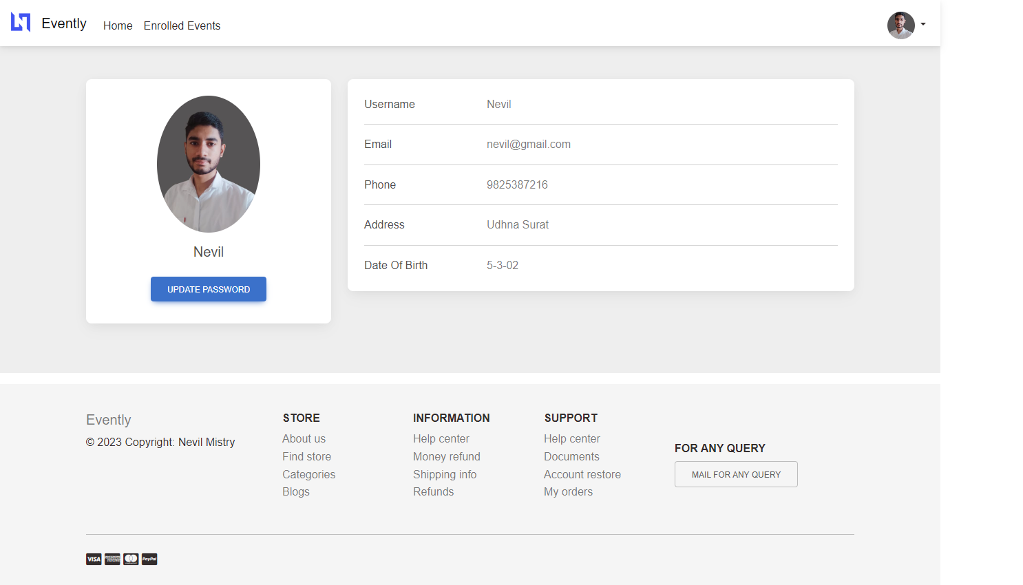

1. Own enrollment page

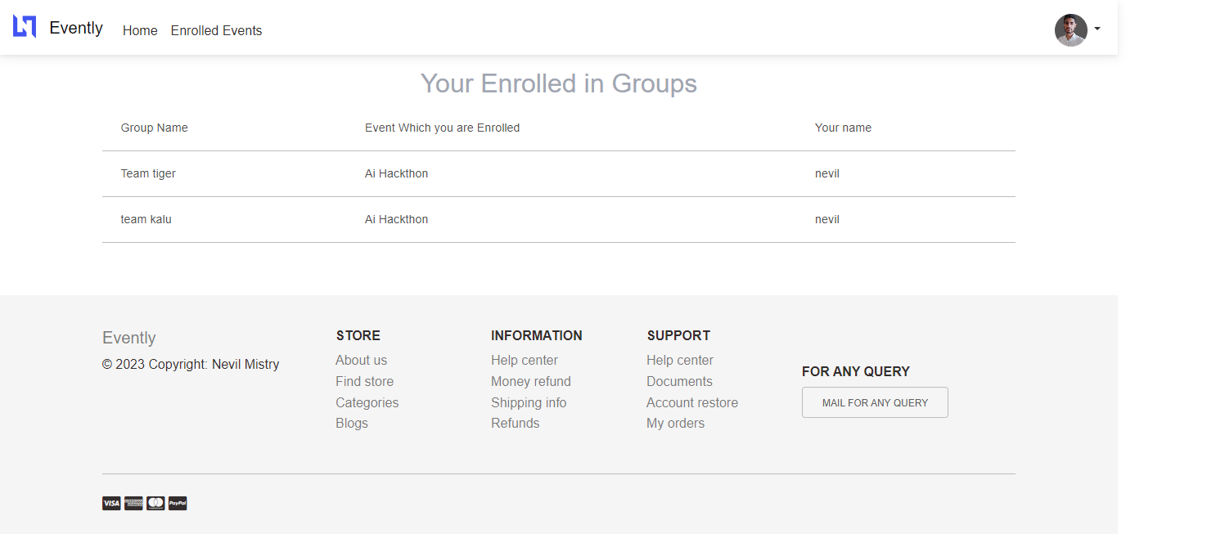

1. Update Password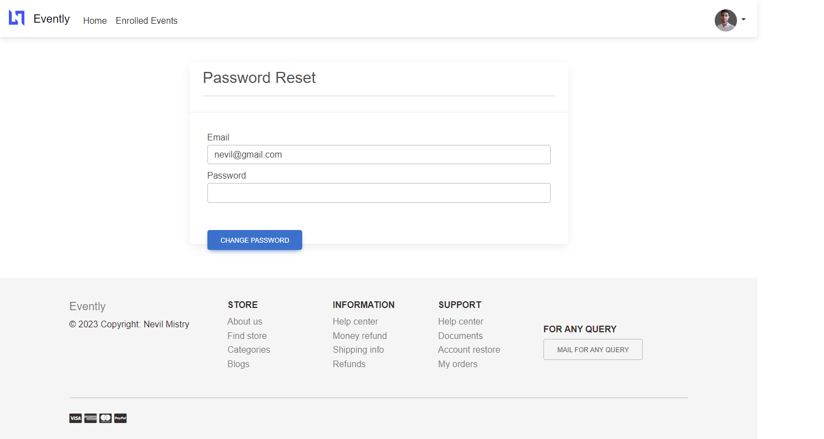

2. Admin side

1. Admin dashboard

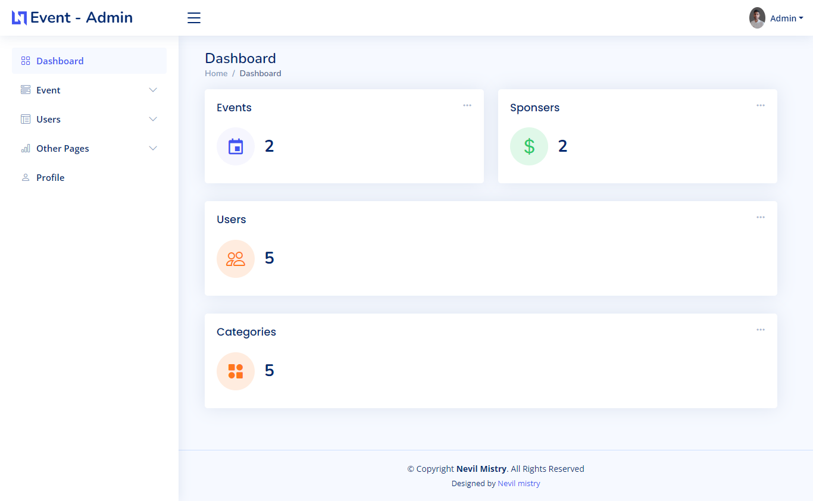

2. Event Display page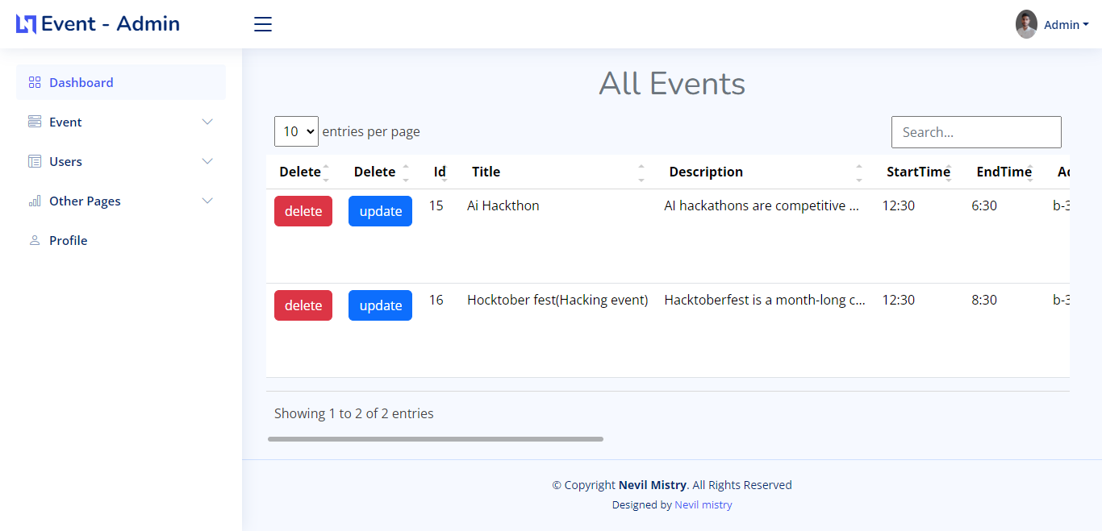

3.Insert event page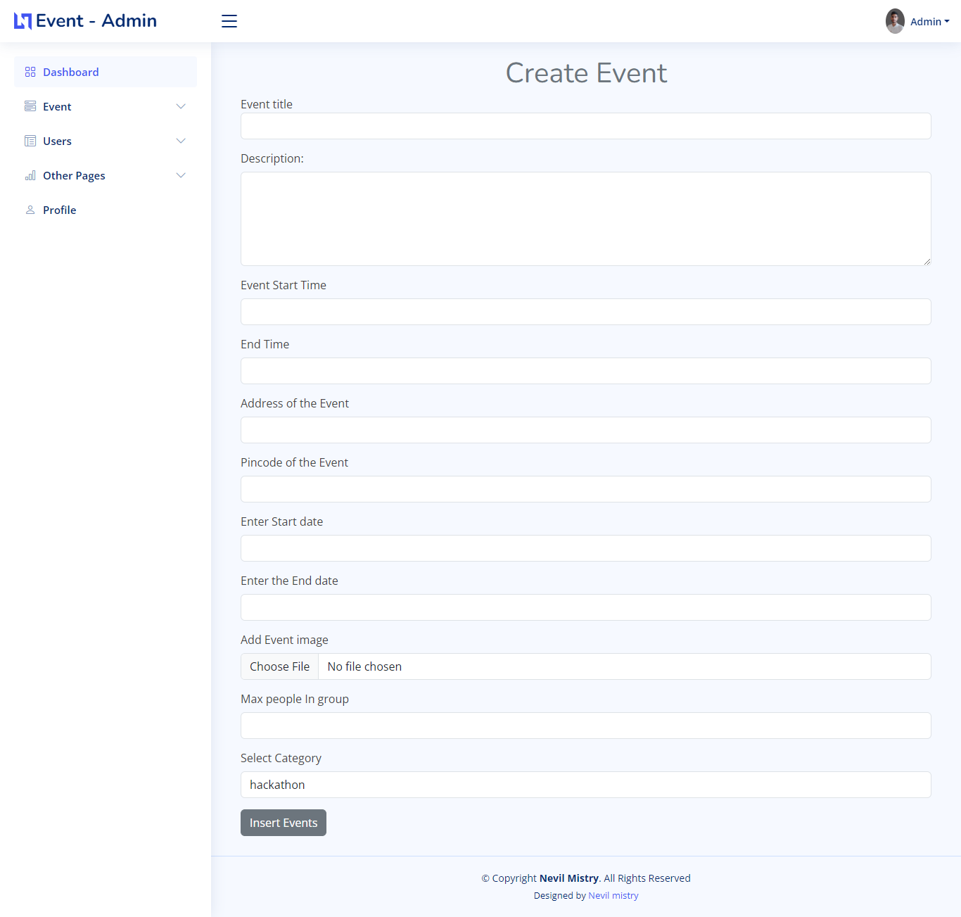

3. All Students

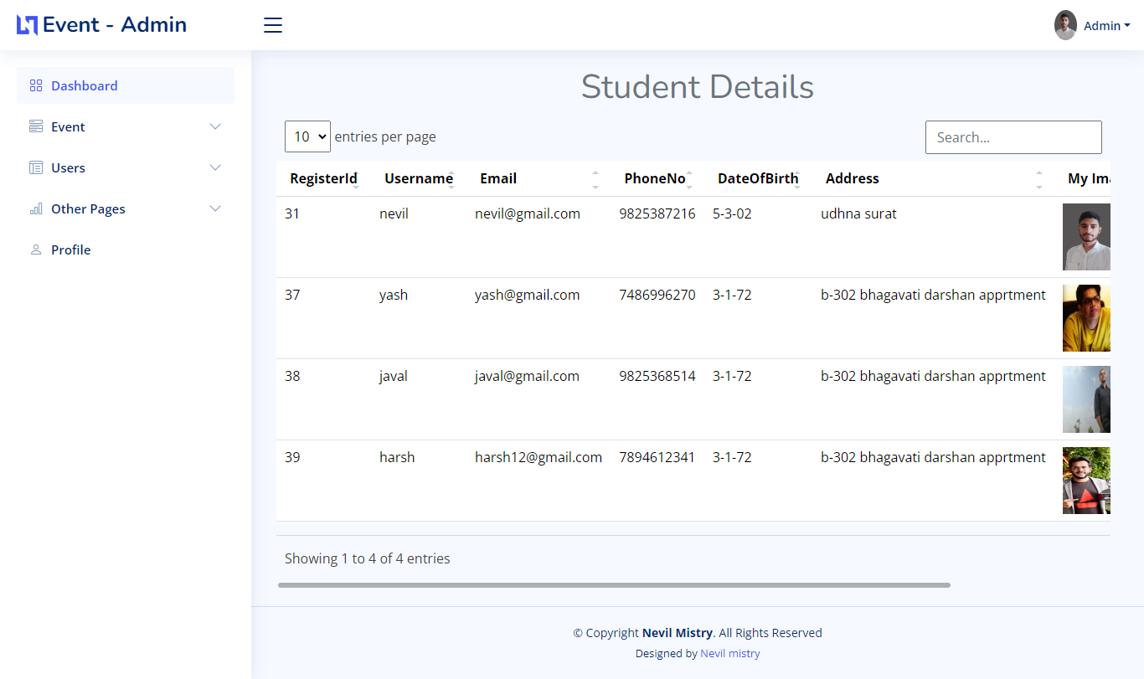

1. All admins

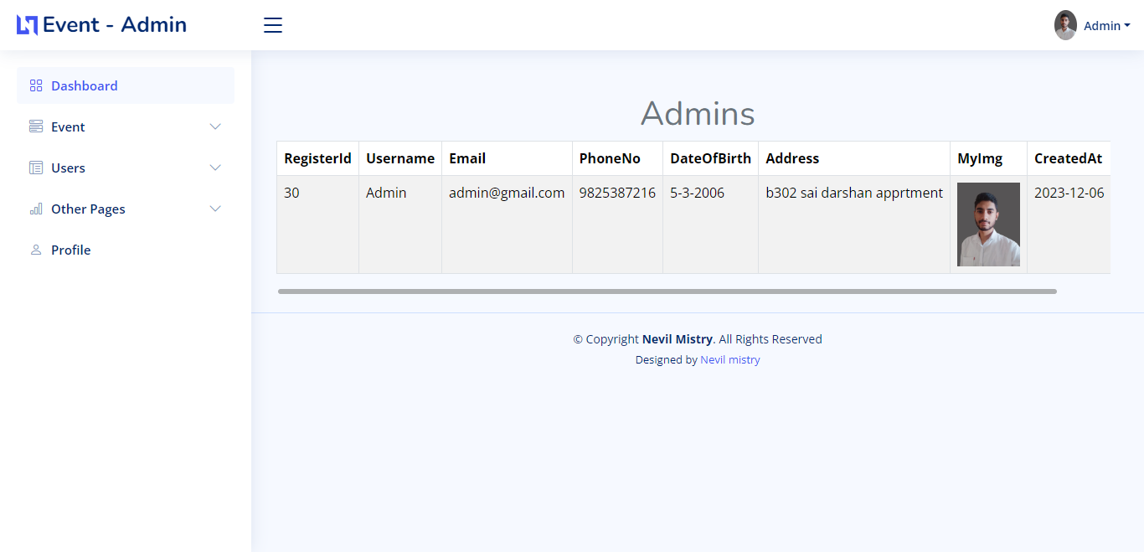

1. All Awards

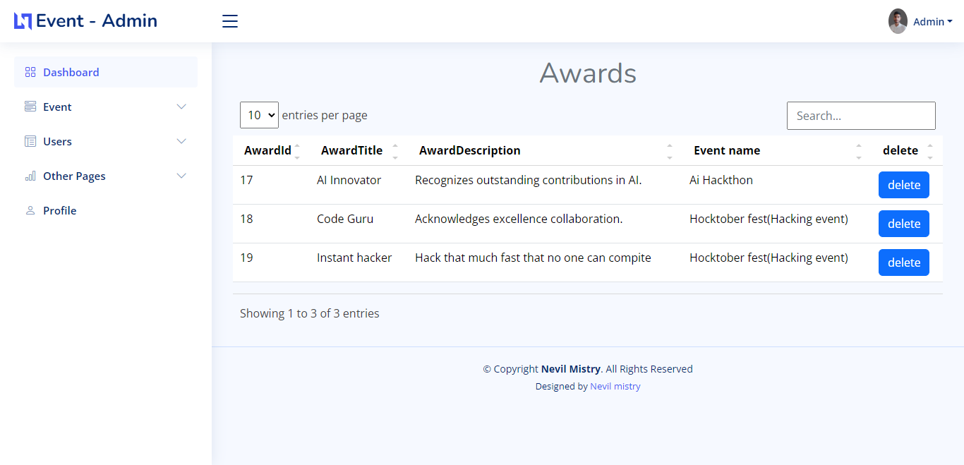

1. Create awards

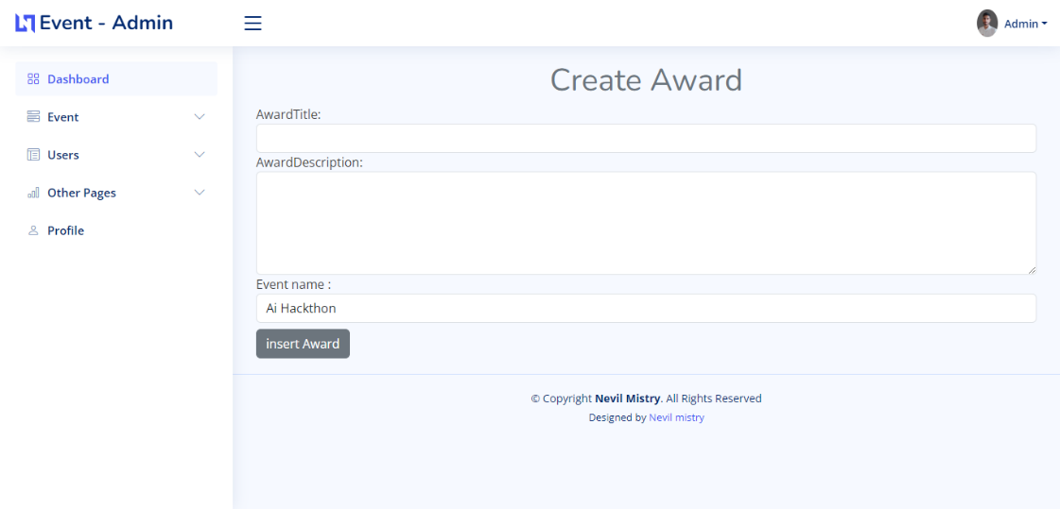

1. Display winners

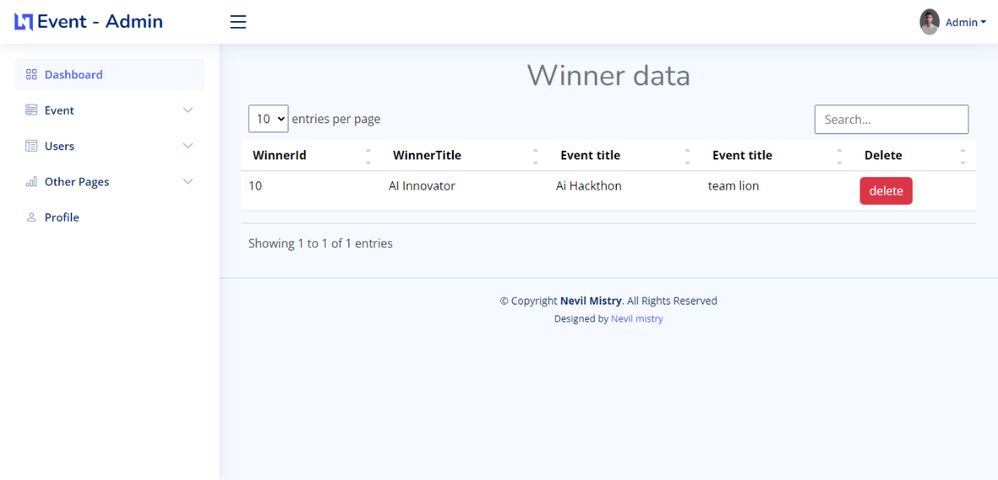

1. Insert winner

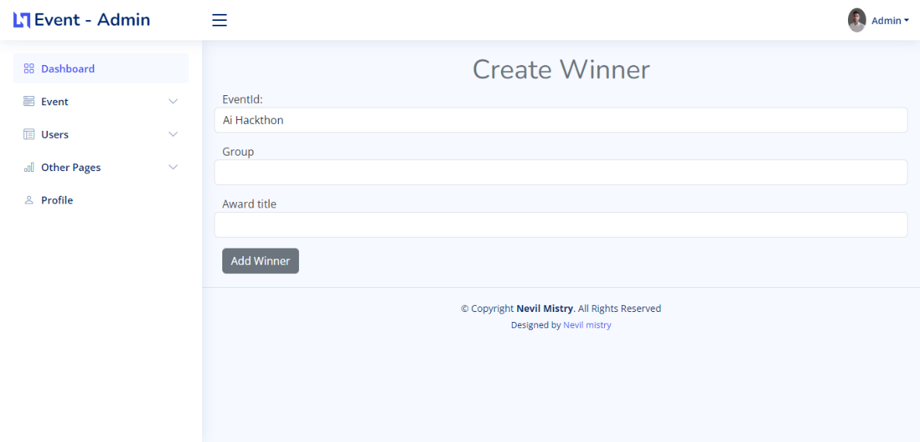

1. Sponser Details

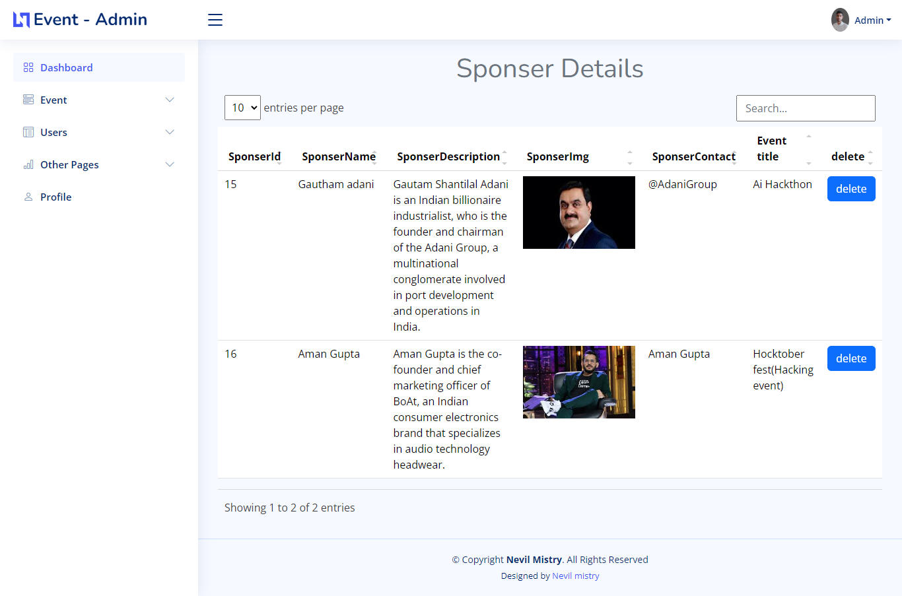

1. Insert Sponsers

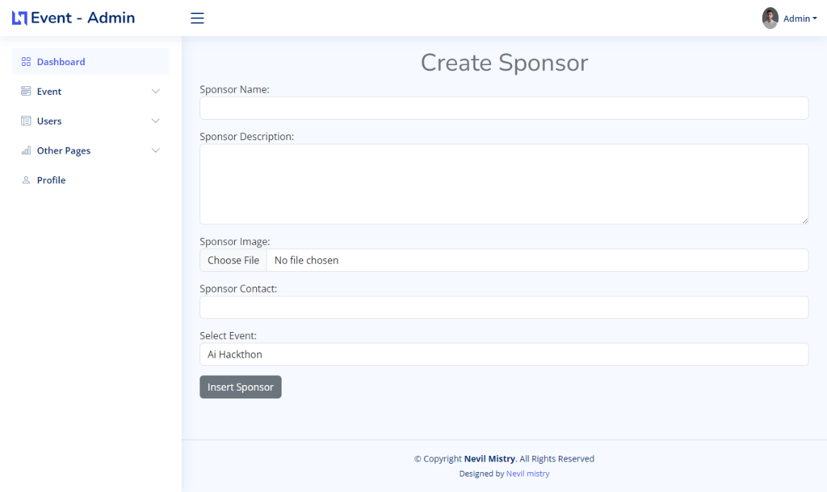

1. Display category

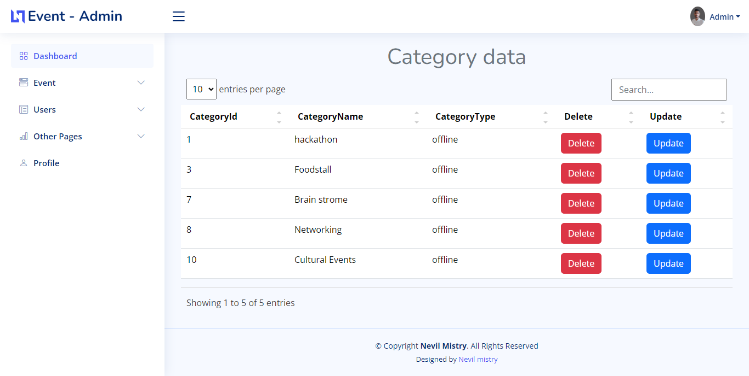

1. Insert category

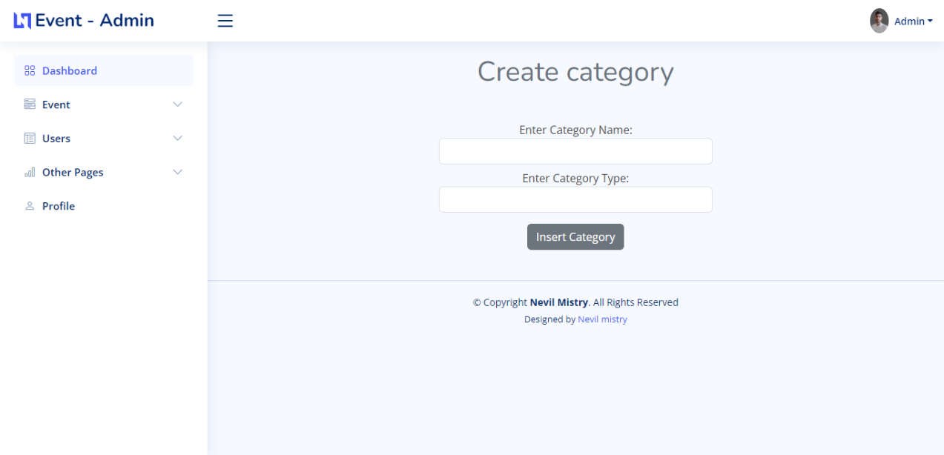

1. Paricipation details by event

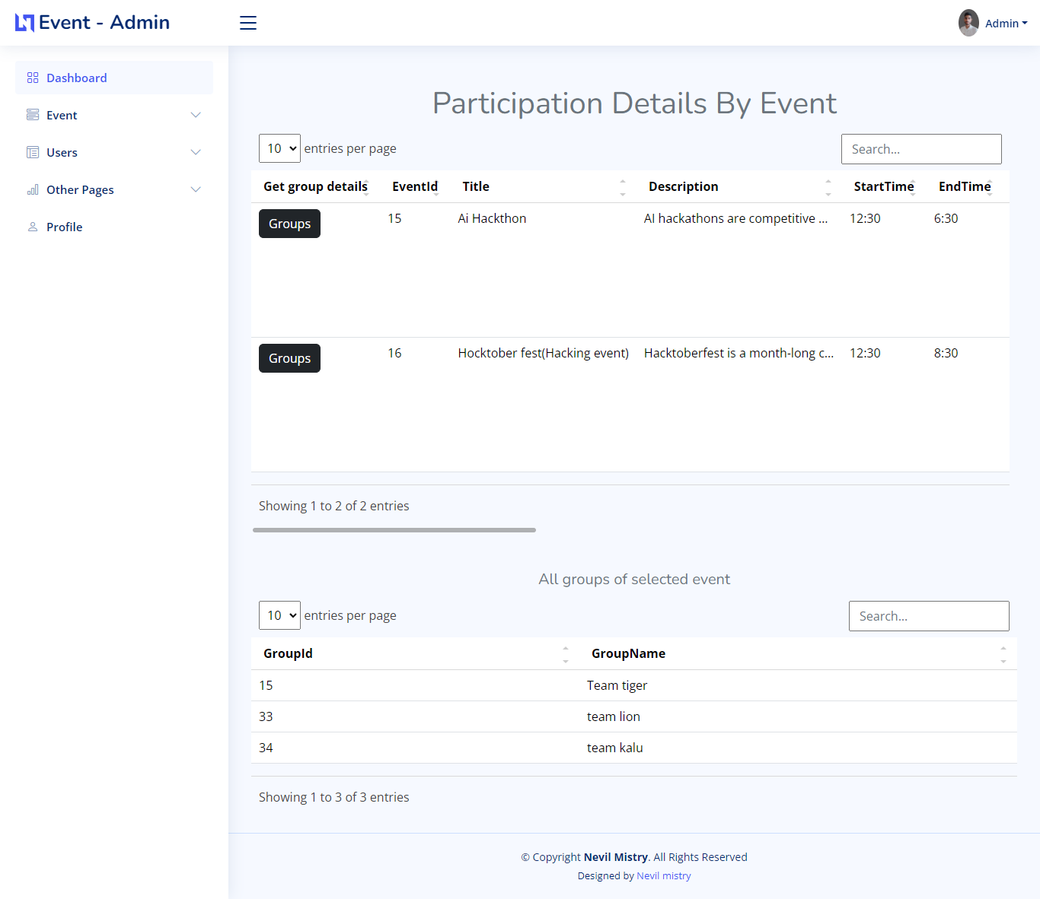

1. Profile page

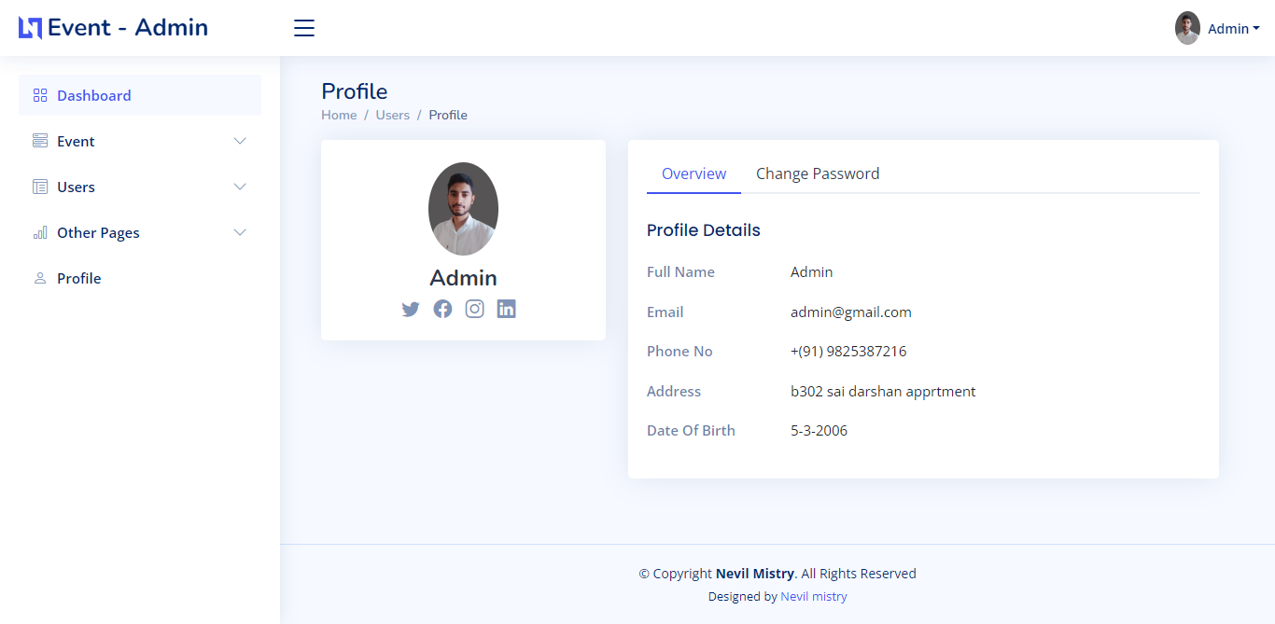

1. update Password

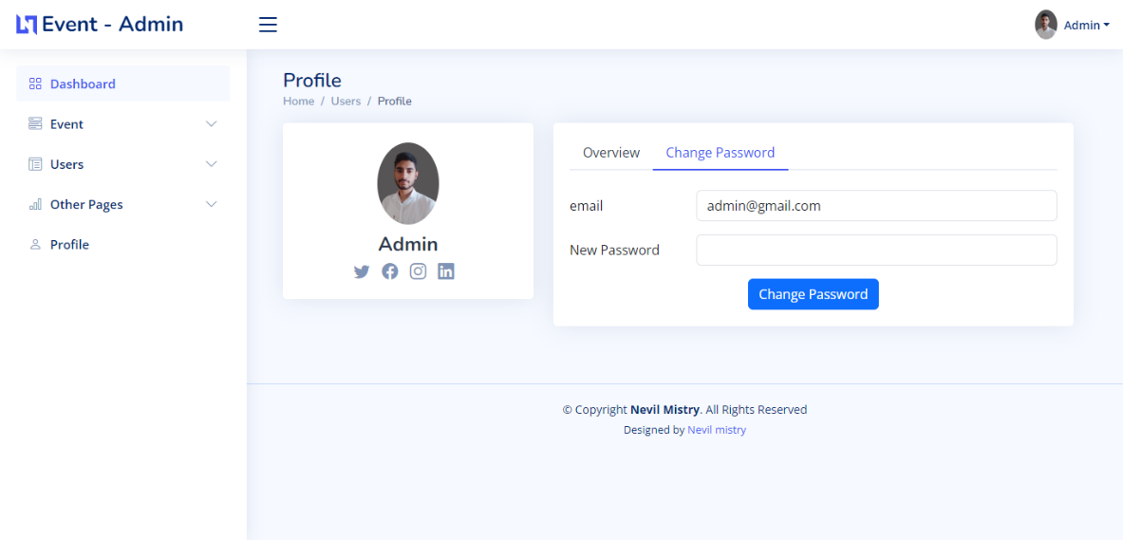

**8.Future scope**

In our future scope we improve our search section of the various types of the Event according to the category. In our event finding section the search will be improved as per the client or user requirement.

In UI modification the scrolling and request handling will be improve as per the user choices. In future the newly and various types of new event will be added in site.

The feedback of our user is very important so , if any feedback given by the user the action for improve that particular section or the entire section will be changed or updated.

The criteria of future scope:

* UI scrolling will be improved
* Request response will be very fast
* Search according to the category
* New event shown first

1. **BIBLIOGRAPHY**
   1. [www.google.com](http://www.google.com)
   2. stack overflow